Population Disparities in New Zealand

<Name>
<Institution Affiliation>
<Course Number and Name>
<Instructor’s Name and Title>
< Date>

Population Disparities in New Zealand
New Zealand has enjoyed a steady growth of population over the past fifty years. The trend is attributed to numerous factors which include ideal governments past political and economic policies
Government’s Past Political and Economic Policies
The government of New Zealand has made numerous policies that affect the economy as well as the political nature of the country. The national leader and politician concentrated on the economic and political prosperity of the country. Agriculture is given priority which contributed to sufficient food production for local consumption as well as export. Cash crops especially horticulture as well as livestock raring boost the economic status of New Zealand. Moreover, the government prioritized reducing the cost of living by making basic needs such as food and education affordable.
The country has enjoyed peaceful coexistence since its independence, (Rush and Obolonkin 2020). Despite a few cases of political and ethnic crisis, the country can be rated as peaceful. The government has also put a lot of effort into public health by making basic health services available at subsidized or zero cost (Charles-Edwards et al 2020). Maternity services have been made free of charge. Besides, children under five years of access to free medical services at no cost. Moreover, some diseases such as tuberculosis and Human Immuno Deficiency Virus (HIV) are treated free of charge. Thus, in New Zealand, the mortality rate has reduced especially for children under the age of five as well as those suffering from killer diseases who are considered vulnerable.
Demographic Trends
The population of New Zealand has grown steadily over the years in the last fifty years. The population of the country was about 2,818,390 in 1970 and by 2020; the population has risen to 4,822,232. Table 1 has shown population growth over the past 50 years.
Years | 1970 | 1980 | 1990 | 2000 | 2010 | 2020
Population | 2,818,390 | 3,146,610 | 3,398,175 | 3,858,992 | 4,370,059 | 4,822,232
Table 1: Population growth of New Zealand over the past fifty years
Source: PopulationPyramid.net (2017)

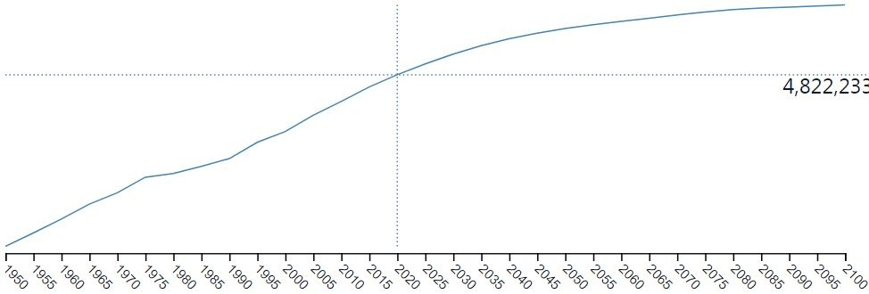Figure 1: Population growth of New Zealand from 1950 to 2100
Source: PopulationPyramid.net (2017)

In the 1970s, the population was largely comprised of children under the age of fifteen. The age between 0 and 15 made about forty percent of the population. 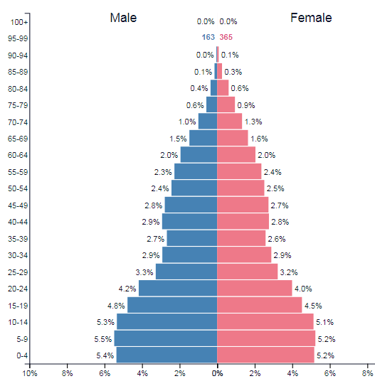
Figure 2: Population of New Zealand in 1970
Source: PopulationPyramid.net (2017)

The percentage of the children as compared to the other population seems to have declined in 2020. Children under fifteen are about 20%.
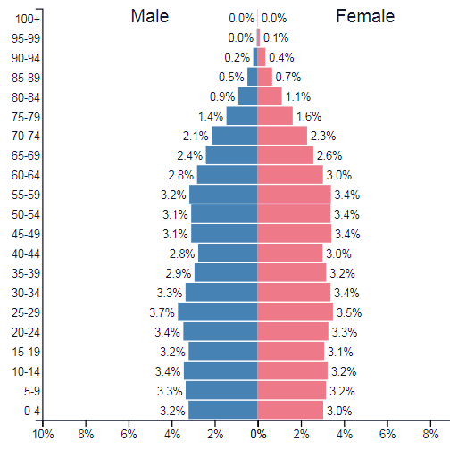
Figure 3: Population of New Zealand in 2020
Source: PopulationPyramid.net (2017)
Connections between Policies and Demographic Trends
From the figures above, the population seems to increase continuously over the years. The population seems to increase as the government policies on food, better healthcare, and affordable basic needs are enhanced. Peace and a favorable environment encourage people to bear more children. Better healthcare reduces mortality rate which leads to population growth.
Population projections
If the current political and economic policies remain in place, the population of New Zealand is expected to rise to almost six million as shown in figure 1. There is expected to have a reduced mortality rate among the children. Therefore, the population will comprise of more men and women than children and teenagers.

References
Charles-Edwards, E., Bell, M., Panczak, R., & Corcoran, J. (2020). A framework for official temporary population statistics. Journal of Official Statistics, 36(1), 1-24.
PopulationPyramid.net (2017). Population Pyramids of the World from 1950 to 2100. Retrieved 13 July 2020, from https://www.populationpyramid.net/world/2017
Rush, E., & Obolonkin, V. (2020). Food exports and imports of New Zealand in relation to the food-based dietary guidelines. European Journal of Clinical Nutrition, 74(2), 307-313.

